Cos 30043 Interface Design

Name: Nur E Siam

Student ID: 103842784

Custom Web Application

URL for webapp: <https://665c44a4f499d13bbe237f16--coruscating-creponne-44dcbe.netlify.app/#/login>

URL for Video demonstration of webapp: <https://youtu.be/91_ZaZzFbY4>

URL for MERCURY NOT WORKING: <https://youtu.be/Zv3V3Hf_aM8>

NES Game Store: Comprehensive Project Overview

Introduction

The NES Game Store is an online platform designed to offer users a seamless and interactive experience in purchasing and exploring various video games. This report details the structure, functionalities, and technologies used in developing the NES Game Store application.

Frontend Overview

The frontend of the NES Game Store is built using HTML, CSS, JavaScript, and Vue.js. The user interface is designed to be responsive, ensuring compatibility across various devices and screen sizes. Bootstrap and custom CSS styles are employed to enhance the visual appeal and usability of the application.

HTML Structure:

The main HTML files include index.html and thank_you.html.

index.html serves as the primary entry point, incorporating essential elements like the navigation bar, content sections, and links to external stylesheets and scripts. It utilizes Bootstrap for responsive design and Vue.js for dynamic content rendering.

thank_you.html is displayed after a successful purchase, providing a confirmation message and a link back to the home page.

CSS Styling:

The main.css file contains custom styles, including font imports, color variables, and layout configurations.

The design focuses on a dark theme with green and red accents, creating a modern and immersive visual experience.

Key elements such as the navigation bar, headers, buttons, and various content sections are styled to ensure consistency and user engagement.

JavaScript and Vue.js:

The main.js file integrates Vue.js components and functionality, enabling dynamic content updates and user interactions.

Key components include the navigation bar, home page, game listings, news, reviews, and payment forms.

Vue Router is used for client-side routing, providing a single-page application (SPA) experience without the need for full page reloads.

Backend Overview

The backend functionality is supported by PHP scripts and a MySQL database. The database, named registration, contains essential tables and data required for the application.

Database Structure:

The database schema is defined in the database.sql file, which includes the creation of tables, insertion of initial data, and necessary configurations.

Tables include user information, game details, payment records, and other relevant data to manage the application's operations.

PHP Scripts:

Key PHP files include db.php and save_payment.php.

db.php handles the database connection, ensuring secure and efficient communication between the application and the MySQL database.

save_payment.php processes payment information, validates input data, and stores the payment details in the database. It also handles redirecting the user to the thank you page upon successful transaction completion.

Data Management

The application uses a JSON file (games.json) to store game information, including titles, descriptions, prices, and image paths. This approach simplifies data management and allows for easy updates and additions to the game listings.

Game Listings:

The games.json file contains an array of game objects, each with properties such as title, content, price, and image.

This data is fetched and displayed dynamically on the games page, providing users with up-to-date information and a visually appealing presentation of available games.

Data Integration:

JavaScript fetch API is used to retrieve data from the games.json file and render it on the frontend.

The integration ensures a smooth user experience, allowing for real-time updates and interactions without requiring page reloads.

User Interaction and Payment Processing

The NES Game Store emphasizes user engagement and streamlined payment processes.

User Authentication:

The application includes a login system managed by Vue.js, where users can log in and access various features.

User authentication status is stored in local storage, ensuring secure and persistent login sessions.

Payment System:

The payment process is handled through a dedicated payment page where users can enter their card details.

The payment form validates user input and submits the data to the backend for processing.

Upon successful payment, users are redirected to the thank you page, confirming the completion of their purchase.

Conclusion

The NES Game Store is a comprehensive web application designed to provide a user-friendly and engaging platform for purchasing and exploring video games. By leveraging modern web technologies and a robust backend infrastructure, the application ensures a seamless and enjoyable user experience. The combination of responsive design, dynamic content management, and secure payment processing makes the NES Game Store a valuable asset in the online gaming marketplace

For the custom webapp hosting I have used Netlify to host my front end due to having issues with my mercury where the webpage was giving me a blank page but the database was working in the in the Swinburne sql. The link for the URl is provided at the top of this report.  
Here are some screenshots of mercury not working along side with my email with my professor.

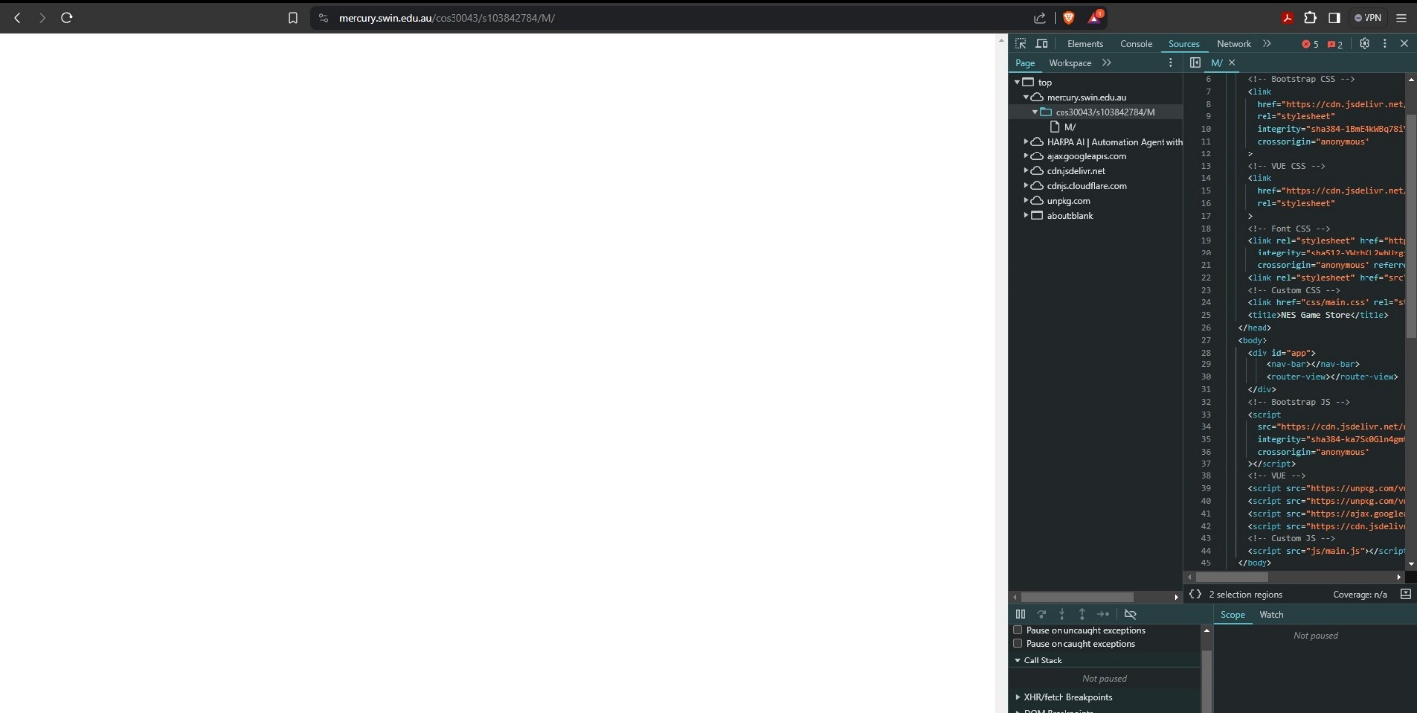

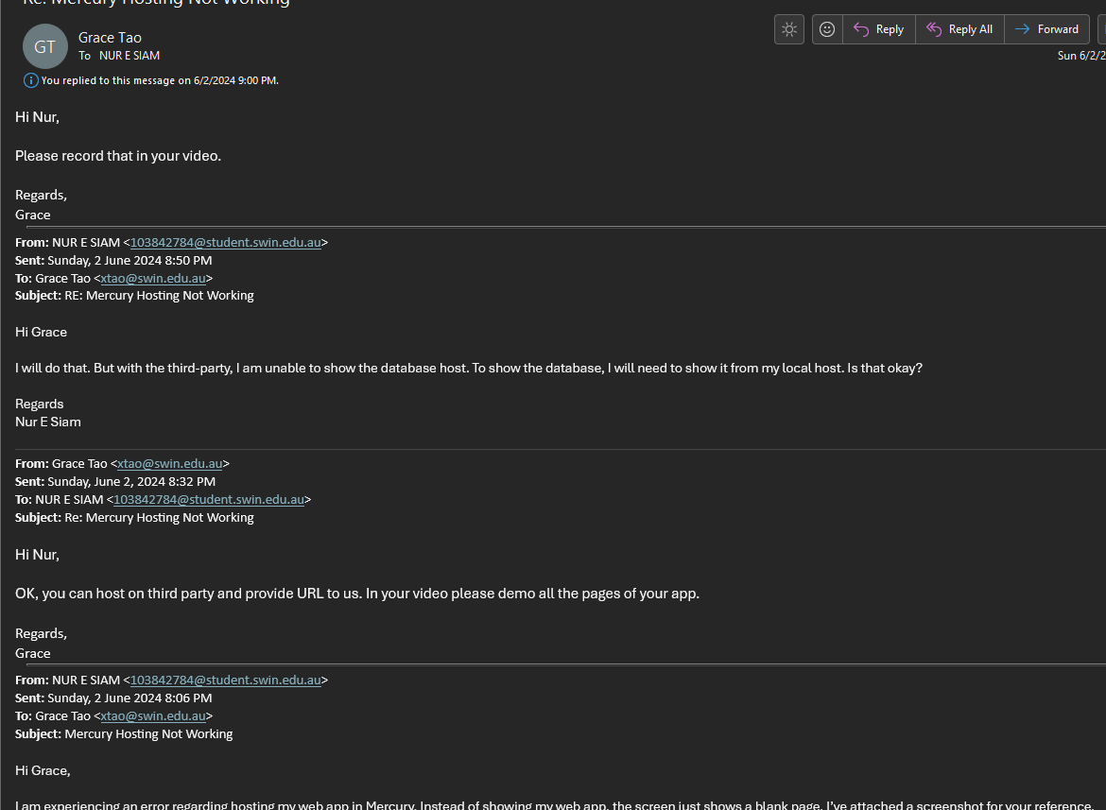

In the demonstration video I have displayed all my pages are working perfectly along side with my database showing the user input.

Here are the Screenshots of my webapp’s everypage including database:  
Login for the web app is user name : admin & password is: siam1234 which is mentioned in the source code readme.txt   
  
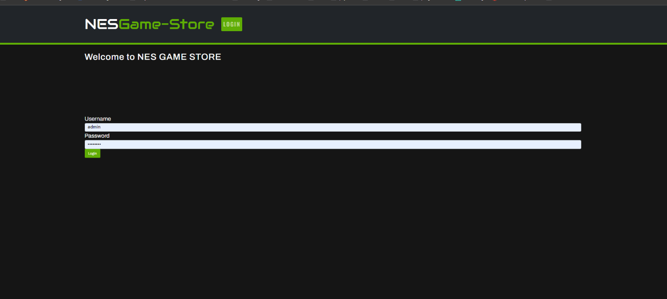

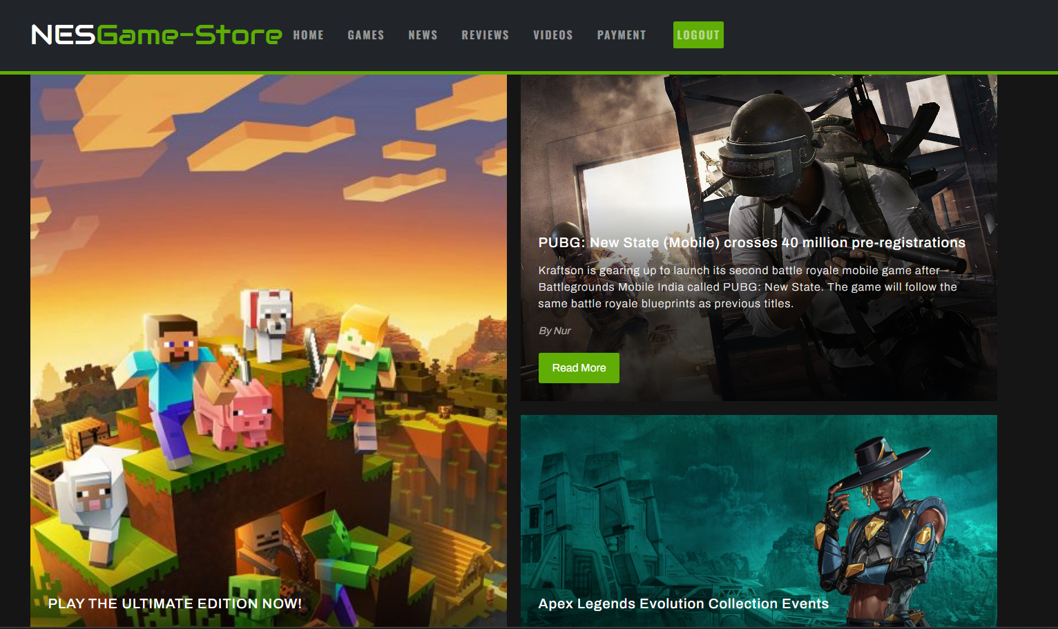

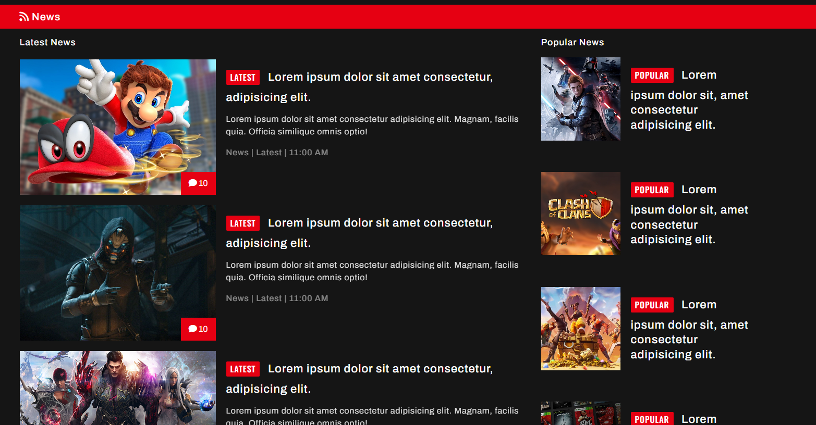

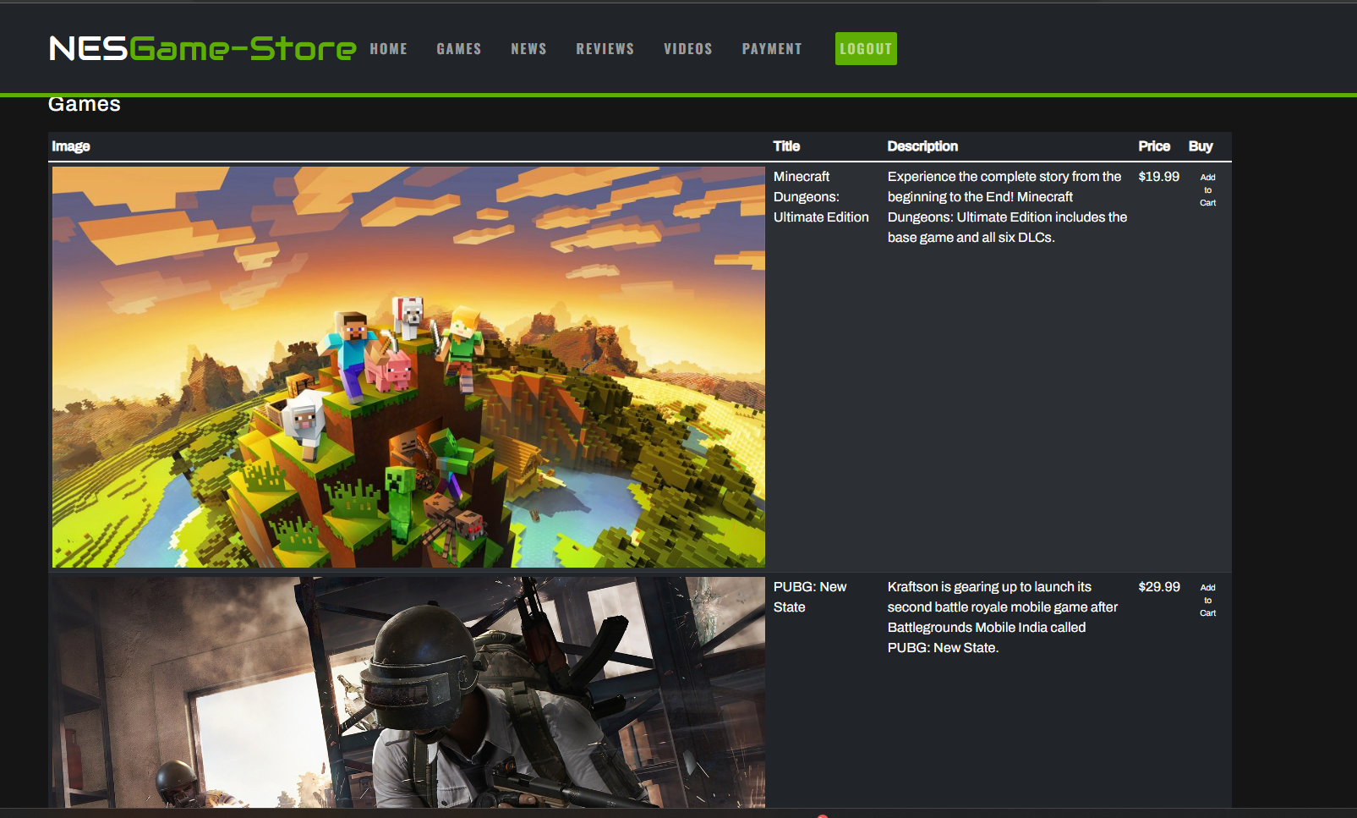

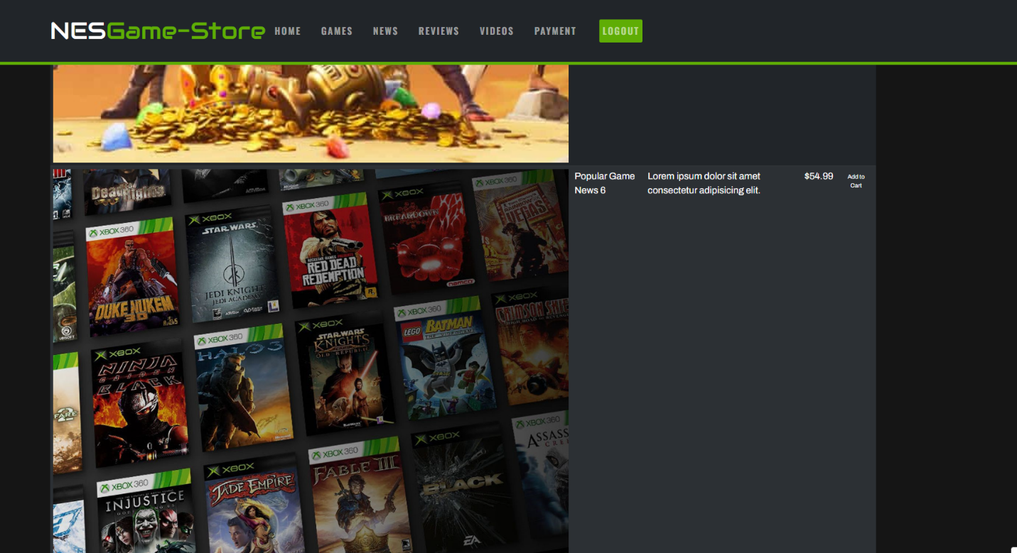

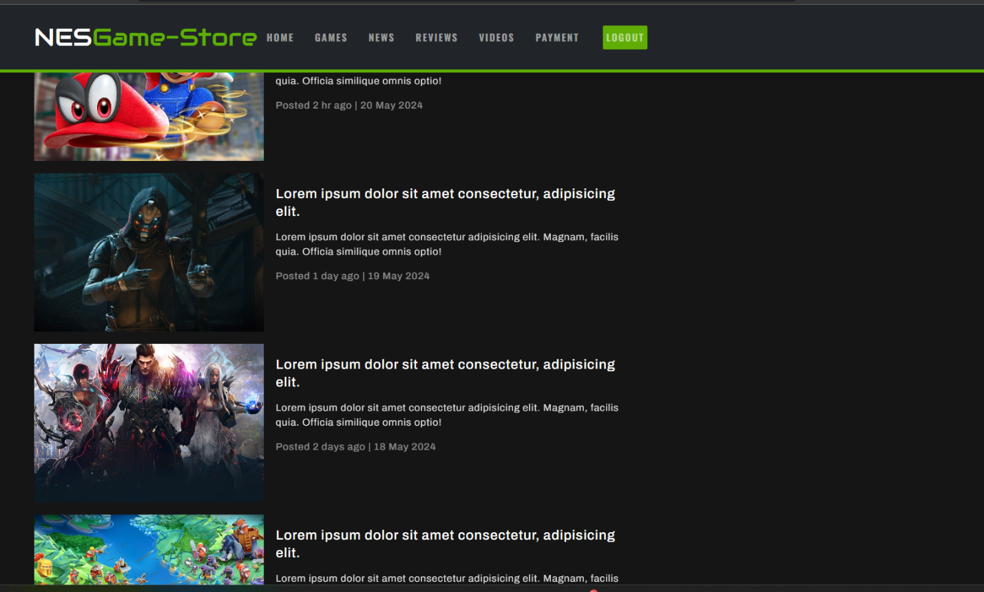

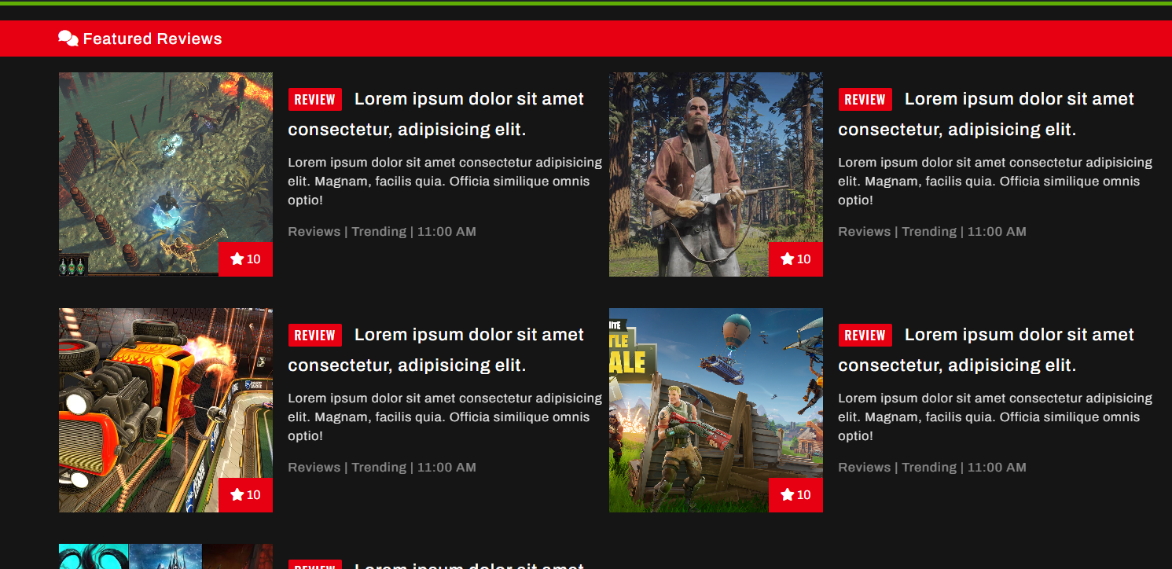

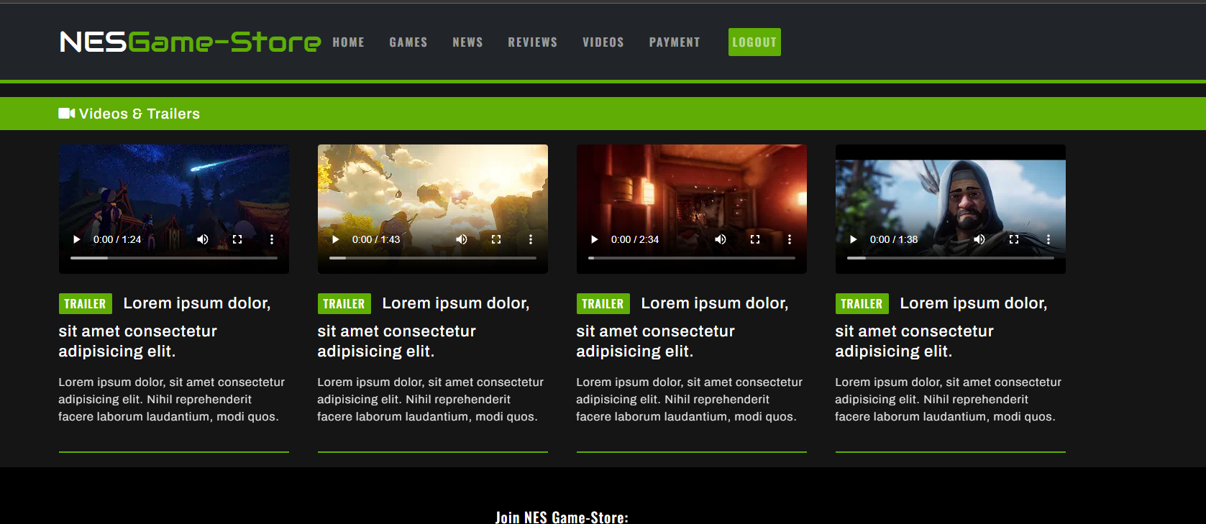

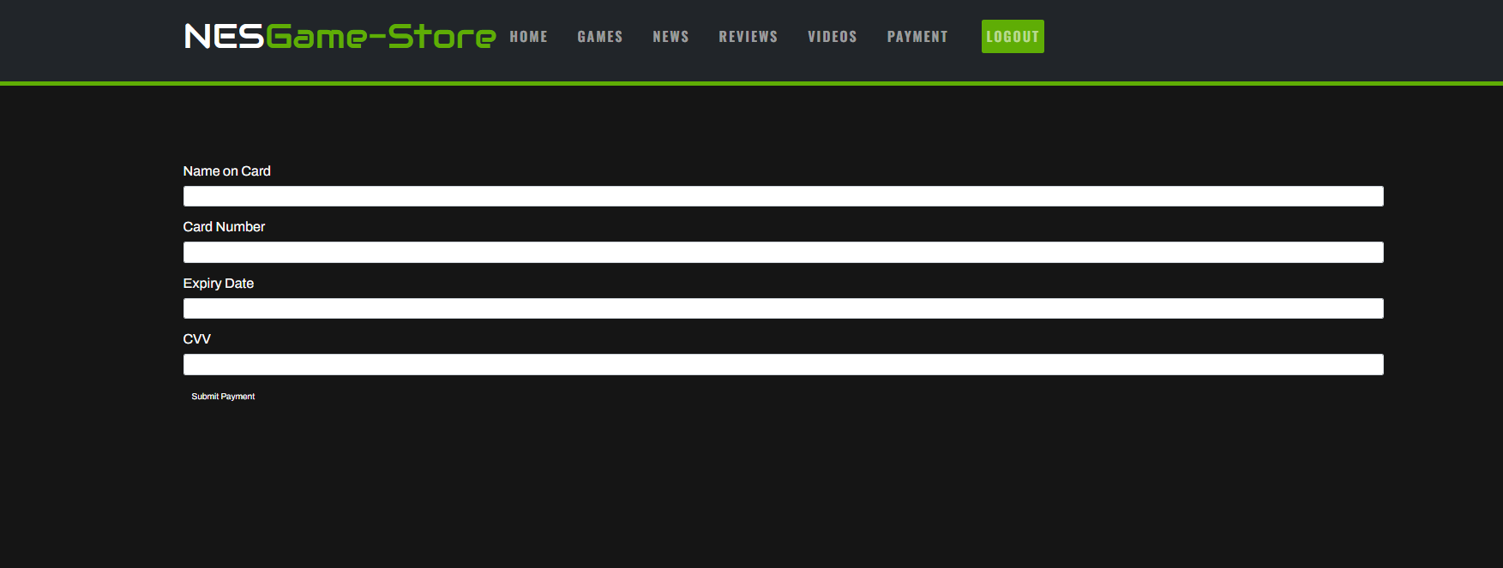

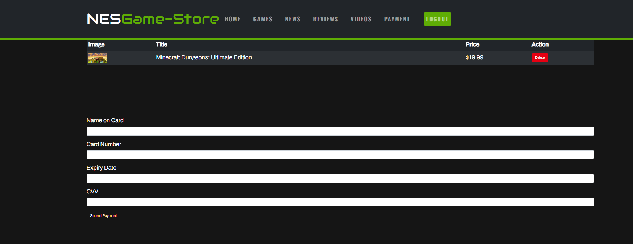



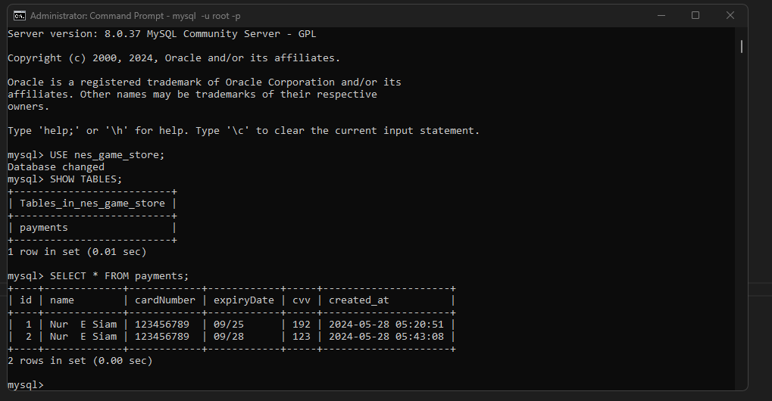

I have also uploaded a video in canvas of my Mercury not working.